Misha Zatsman
M. Eng project
May 17, 2002

Defining and Discovering Clusters on the Internet

Motivation

We introduce a content-blind approach to finding similar pages. It is a non-iterative application of Kleinberg’s hubs and authorities algorithm [Kle 99].

Although Kleinberg suggests using his algorithm to finding similar pages, he limits his view to the problem of finding pages similar to a one particular page. He arbitrarily chooses the set of pages pointing to the desired page as the base set. Finally his approach uses his standard hubs and authorities and there fore must be run iteratively. Therefore we believe the two advantages over Kleinbergs are as follows:
- Better definition of problem by specifying set of base pages.
- Better choice of seed for algorithm.
- Better performance through non-iterative approach.
- Simpler model with non-iterative approach.

Past Approaches
The shortcoming of past approaches is that they attempt to find pages similar to one particular page. This is a very challenging problem. The problem is not simply one of “parsing” the page. Consider the following example. Jeff is an assistant professor in Plant Science at Cornell University, he is from California, speaks Spanish fluently, enjoys mountain biking and painting. All these facts are evident from Jeff’s homepage. Extracting all these features from the webpage would by itself be an impressive accomplishment in natural language processing. Assuming we had the features, we would then have to determine which features are relevant to the user. Finally we would need to find other new pages that contain the relevant features.

We can divide this problem into 3 components:
- Extracting features from a webpage.
- Deciding which features are relevant.
- Finding other pages that contain the relevant features.

Step 1 is hard, but let’s assume that it can be done. If we can do step 1 then we can do step 3, simply by running step 1 on each page, and indexing all the features. I claim that step 2 is impossible, since different users will be interested in different features from the same webpage. In our example above, the first user might be interested in Jeff’s page because it is about mountain biking, while another might be looking for plant science researchers.

Algorithm

Our approach takes a small set (on the order of 10) of pages. This set “describes” what the user is looking for, presumably irrelevant features will not appear in all the pages and therefore will be given less weight than features that are identical across all the pages. Similar to the approach in [DH 99] we take advantage of the concepts of Hubs and Authorities [Kle 99] to exploit link structure both in discovering candidate pages and in ranking the results. Since we use a set of base pages, we don’t need to run the algorithm iteratively (as in [Kle 99],[DH 99]), and are therefore less susceptible to topic drift.

The algorithm builds the following sets:
Base – pages entered by the user.
Authorities – pages that link the base pages.
Hubs – pages that the base pages link to.
Candidates – pages authorities link to or link to base pages.

These sets are not necessarily disjoint. Indeed we would hope that the base pages show up in the set of candidate pages.

Scoring
Scores are then computed as follows:
Authority score is the number of base pages that the page points to.
Hub Score is the number of base pages that point to the page.
Candidate score is the sum of the authority scores of the pages that point to it and the hub scores of the pages that it points to.

The sets are then returned to the user, with the pages listed in order of decreasing score. The hub and authority sets might be useful to the user (and are certainly useful to us for evaluation) so we return them as well as the set of candidates.

Clipping
To lower the number of pages and reduce the influence of a single page we sometimes require two pages to “speak for” a page before it is added to the graph, we call this clipping since it removes pages from the result set. This strategy lowers the number of resulting pages, but with small sets it might be prohibitive. A more dynamic strategy would adjust these numbers in response to the size of the sets. Instead we simply had 3 switches on the program, specifying whether authority, hub, and candidate pages would be required to have two pages to speak for them. We found good performance requiring only candidate pages to be spoken for by two pages. This is justified since candidate pages that are only spoken for by one page are unlikely to be good matches. It could happen that a candidate page is simply spoken for by one high-scoring authority or hub page. On the other hand authority and hub pages that are only spoken for by one base page may still be relevant, and since they can only add a score of 1 to potential candidates, the damage they do is limited.

The reason we require this clipping is to lower the effects of irrelevant links. Some evidence of this can be seen in the popular websites (e.g. yahoo.com, google.com) which show up because they appear on multiple pages. One solution [HENZINGER] to this problem is to handcraft a list of ignored sites. Although this is certainly a possible approach we chose to avoid such handcrafted approaches. A solution to the more general problem of irrelevant links would be to weigh the influence of a node by the number of incoming or outgoing edges. The score an authority page can contribute to a candidate page is its score divided by the number of outgoing links. This approach has the problem that pages which contain relevant links and irrelevant links are punished. Consider for example a page that contains information for people moving to an area. Imagine that this page contains links to both housing and moving websites. A weighted approach would discount the scores given to the housing pages because they appear on the same page as the moving links. Instead we take the more conservative approach. We assume that the pages are all equally relevant and optimistically assume that the moving links will not appear in the result set. If they do, then it can be argued that they belong there.

Results
We will now present our results for 5 different types of queries. We will give the base set as well as the first 10 candidates returned (with their candidate score). For full results see the appendix.

Algebra sites
Base Set:
http://matti.usu.edu/nlvm/enu/navd/topic_t_2.html
http://mathforum.org/algebra/k12.algebra.html
http://math.sierra.cc.ca.us/Algebra/algebra.htm
http://www.rice.edu/armadillo/Algebra/Lessons/
http://archives.math.utk.edu/topics/algebra.html
http://www.algebrahelp.com/lessons/simplifying/multiplication/
http://www.mathnotes.com/aw_introalg.html
http://www.algebrahelp.com/lessons/factoring/
http://www.mathnotes.com/aw_student_note.html
http://mtl.math.uiuc.edu/projects/5/
http://math.sierra.cc.ca.us/Algebra/AlgReview/algebrareview.htm

Candidates:
21: http://www.algebrahelp.com/
15: http://www.mathnotes.com/aw_introalg.html
11: http://www.mathnotes.com/aw_intermediate.html
7: http://www.mccc.edu/~kelld/page200.html
7: http://www.cut-the-knot.com/algebra.html
7: http://www.harcourtschool.com/glossary/math/index.html
7: http://www.shodor.org/interactivate/lessons/index.html
7: http://www.mathpower.com/
5: http://www.nsa.gov/programs/mepp/hsalg.html
5: http://www.shodor.org/interactivate/activities/index.html

Matrix Sites
Base set:
http://www.lse.ac.uk/Depts/statistics/
http://phase.hpcc.jp/mirrors/MatrixMarket/compression.html
http://pages.infinit.net/rlevesqu/spsstips.htm
http://www.netlib.org/scalapack/
http://links.math.rpi.edu/index.html
http://ocean.st.usm.edu/~jstuart/index.html
http://www.mathnotes.com/Intro/aw_introchap7.html
http://scientium.com/drmatrix/sciences/scitech.htm
http://www.ph.unimelb.edu.au/~jpc/dviview/
http://emmy.math.uni-sb.de/~simath/
http://www.atmos.washington.edu/gcg/SV.man/sv.31plotsat.html
http://www.coe.uncc.edu/~zbyszek/gcreadme.html
http://www.wm.edu/CAS/MINEQ/matrix.html
http://phase.hpcc.jp/mirrors/MatrixMarket/structureplots.html
http://math.nist.gov/MatrixMarket/compression.html

Candidates:
25: http://phase.hpcc.jp/mirrors/MatrixMarket/compression.html
15: http://phase.hpcc.jp/mirrors/MatrixMarket/resources.html
13: http://phase.hpcc.jp/mirrors/MatrixMarket/search.html
10: http://www.acm.org/calgo/compression.html
6: http://netlib.bell-labs.com/netlib/bib/compression.html
3: http://theory.lcs.mit.edu/~rivest/crypto-security.html
3: http://www.ssh.fi/tech/crypto/algorithms.html
3: http://www.adel.nursat.kz/apg/

Database Researchers
Base:
http://www-db.stanford.edu/~sergey/
http://s2k-ftp.cs.berkeley.edu:8000/nasa_e2e/mike.html
http://www.cs.cornell.edu/johannes/
http://www.almaden.ibm.com/cs/people/peterh/
http://www.cs.wisc.edu/~raghu/raghu.html
http://www.cs.cornell.edu/zhychen/
http://www-db.stanford.edu/people/hector.html
http://www1.bell-labs.com/user/poosala/
http://www.cs.wisc.edu/~yannis/yannis.html
http://www.cs.cornell.edu/People/jai/

Candidates:
16: http://www-db.stanford.edu/people/hector.html
13: http://www.cs.wisc.edu/~raghu/raghu.html
12: http://www-db.stanford.edu/~sergey/
11: http://www-db.stanford.edu/people/gio.html
11: http://www.cs.rutgers.edu/~imielins/index.html
11: http://www.bell-labs.com/user/avi/
11: http://www-db.stanford.edu/~ullman
10: http://www.cs.cornell.edu/johannes/
9: http://www.bell-labs.com/user/hfk/
9: http://www-db.stanford.edu/people/wiener.html

Car Manufacturers
Base:
http://www.gm.com/
http://www.ferrari.com/
http://www.ford.com/
http://www.mercedes.com/
http://www.bmw.com/
http://www.jaguar.com/
http://www.toyota.com/
http://www.volkswagen.com/
http://www.chrysler.com/
http://www.porsche.com/
http://www.lexus.com/
http://www.subaru.com/

Candidates:
460: http://www.toyota.com/
425: http://www.honda.com/
389: http://www.ford.com/
384: http://www.porsche.com/
337: http://www.audi.com/
327: http://www.gm.com/
326: http://www.lexus.com/
325: http://www.subaru.com/
324: http://www.cadillac.com/
319: http://www.bmw.com/

San Francisco Bay Area apartment listings
Base:
http://www.renttech.com/web/
http://cyberrentals.com/CA/SFCA.html
http://www.sfgate.com/rentals/
http://open-news.pacbell.net/drn-bin/wwwnews?ba.market.housing
http://www.metrorent.com/
http://www.rentalguide.com/
http://www.relocationcentral.com/directory/us/ca/mountain-view-area/apartments/
http://bayarea4rent.com/
http://valleyjobs.com/apartments.html
http://www.bayrentals.net/
http://www.craigslist.org/sfo/pen/apa/

Candidates:
32: http://www.metrorent.com/
21: http://www.rentalguide.com/
14: http://www.renttech.com/
12: http://www.sfgate.com/rentals/
8: http://www.rentalsolutions.com/
8: http://www.sftu.org/
8: http://www.craigslist.org/
7: http://www.werent.com/
7: http://www.ci.sf.ca.us/rentbd/

Effects of Base Set size
We ran the last set (SF bay area apartments) with varying base set sizes to explore the relationship between base set size and quality of candidates. To measure the quality of the candidates, we simply examined the returned pages and decided if they would be useful to someone looking for apartment listings in the bay area. See the graph below.

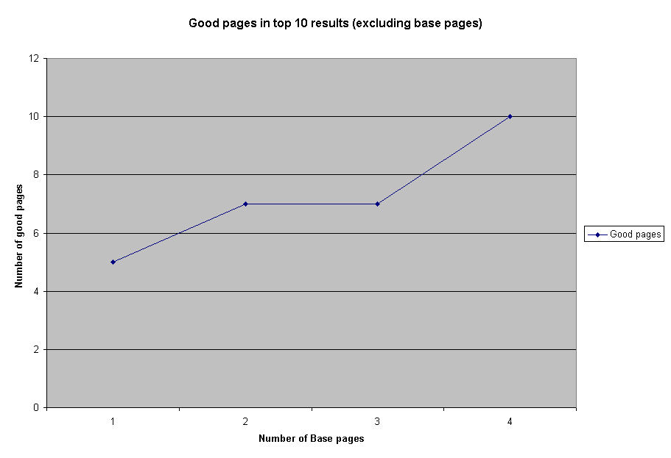
Clearly the quality improves with the size of the base set. We explored this all the way up to 10, but with base pages of sizes larger than 4 the quality in the top 10 pages cannot improve. That does not mean that improvement stopped; indeed as the base set grew so did the number of relvant candidates, this improvement simply was not seen further in the top ten results. See the appendix for full results.

Use of Hubs and Authorities
The different types of searches performed relied on hubs and authorities differently. Both of the commercial searches (car manufacturers and apartment listings) produced few hubs since commercial sites do not tend to link to each other. The other end of the extreme was the set of matrix computation pages, which produced no authorities, but plenty of hubs.

References
[DH 99] Jeffrey Dean and Monika R. Henzinger. Finding Related Web Pages in the World Wide Web. Proceedings of the 8th International World Wide Web Conference (WWW8), 1999, pp. 389-401.
[Kle 99] Jon Kleinberg. Authoritative sources in a hyperlinked environment. Proc. 9th ACM-SIAM Symposium on Discrete Algorithms, 1998. Extended version in Journal of the ACM 46(1999).

Appendix
Note that running times are approximate and were performed on different machines, so they should simply be considered a rough estimate. Also some runs come from earlier versions of the code. If it is unspecified, full clipping (authorities, hubs, and candidates) was used.

These files are available online since they are too large to include in this report.
http://misha.zatsman.com/sim/results

